**ANAYLSING COVID-19 and ITS IMPACT**

**By: Utpal Mishra (20207425)**

**Under the supervision of**

**Dr. Aine Bryne**



**DATA AND COMPUTATION SCIENCE**

**UNIVERSITY COLLEGE DUBLIN**

**BELFIELD, DUBLIN 4, IRELAND**

**ANAYLSING COVID-19 and ITS IMPACT**

**By: Utpal Mishra (20207425)**

**Under the supervision of Dr. Aine Bryne**

**Submitted to the Department of Mathematics and Statistics in partial fulfilment of the requirements for the degree of Master’s in Data and Computation Science.**



**DATA AND COMPUTATION SCIENCE**

**UNIVERSITY COLLEGE DUBLIN**

# BELFIELD, DUBLIN 4, IRELAND

# CERTIFICATE

This is to certify that Project Report entitled “**Analysing COVID-19 and its Impact”** which is submitted by **Utpal Mishra,** in partial fulfilment of the requirements for the award of master’s degree in Data and Computational Science at University College Dublin, is a record of the candidate's own work carried out by him under my supervision. The matter embodied in this thesis is original and has not been submitted for the award of any other degree.

**Supervisor: Dr. Aine Bryne**

**Date: 12th December 2020**

### ACKNOWLEDGEMENT

*It gives us a great sense of pleasure to present the report of the Master’s Project undertaken during the Autumn Trimester. I owe a special debt of gratitude towards* ***Dr. Aine Bryne*** *School of Mathematics and Statistics, University College Dublin, Dublin, Ireland for his constant support and guidance throughout the course of our work. His sincerity, thoroughness and perseverance have been a constant source of inspiration for us. It is only his cognizant effort that our endeavours have seen the light of the day.*

*I also do not like to miss the opportunity to acknowledge the contribution of all faculty members of the department for their kind assistance and cooperation during the development of our project.*

*Name: Utpal Mishra*

*Student Number: 20207425*

*Date: 12th December 2020*

### TABLE OF CONTENTS

**CONTENT PAGE NO**.

**CERTIFICATE .................................................................…………… iii**

**ACKNOWLEDGEMENTS .............................................................… iv**

**LIST OF TABLES........................................................................ vi**

**LIST OF FIGURES....................................................................... vii**

**LIST OF SYMBOLS ..................................................................... viii**

**LIST OF ABBREVIATIONS ............................................................. ix**

**OBJECTIVE……………………………………………………………………………………….…………….. x**

**CHAPTER 1: INTRODUCTION………………………………………………………………...11**

**CHAPTER 2: ANALYSIS……………………………………………………………………..…..13**

**ABOUT DATA……………………………………………………………………..13**

**AIR POLLUTION…………………………………………………………….……14**

**CASES INVESTIGATION………………………………………………………16**

**MEDICAL STRATEGIES……………………………………………………….18**

**TESTING INTERPRETATIONS…………………………………………….19**

**CHAPTER 3: RESULTS AND CONCLUSION……………………………………….…….20**

# 

# REFERENCES…………………………………………………………………………………………….22

# LIST OF TABLES

**CONTENT PAGE NO**.

1. Table 1: List of details of datasets used in the project………………………….14

# LIST OF FIGURES

**CONTENT PAGE NO**.

1. Figure 1: Dynamic scattered orthographic plot of world

population (logarithmic of population) from 1960 to 2020……………………………….12

1. Figure 2: Total count of pollutants (CO, NO2, O3, PM1,

PM10, PM2.5, SO2) in the Countries and in their Cities…………………………………….13

1. Figure 3 and 4: Statistical Interpretations on Air Pollution……….…………15
2. Figure 5: Dynamic plot representing the metamorphosis on

the amount of air pollutants from January 2020 to May 2020………………………….15

1. Figure 6: Bar-plot for different cases (i.e., Confirm Cases,

Admit Cases and Discharged Cases) in Ireland from last March 2020

to mid-September 2020……………………………………………………………………………………..16

1. Figure 7: Folium map for COVID cases in Ireland over 7

Months………………………………………………………………………………………………………………..17

1. Figure 8: Confirm COVID cases in different county in Ireland

from end January 2020 to early September 2020……………………………………………..17

1. Figure 9: Proportion of population affected with COVID in

different Ireland County from end January 2020 to early

September 2020………………………………………………………………………………………………….18

1. Figure 10: An important aspect of COVID is the pattern of

spread of disease in different phases i.e., Travel Abroad, Close

Contact and Community Transmission……………………………………………………………….18

1. Figure 11: Different age group of total citizens affected from

COVID from March 2020 to September 2020……………………………………………………..19

1. Figure 12: Total number of testing performed in different

labs i.e., in Hospital Labs and in Non-Hospital Labs from January

2020 to September 2020…………………………………………………………………………………….19

1. Figure 13: Response of the countries to the new cases and

the tests performed…………………………………………………………………………………………….19

1. Figure 14: Value of Euros vs other currencies from Jan 2020

to mid-October 2020…………………………………………………………………………………………..20

1. Figure 15: Unemployment in the world from 1960 to 2020……………………21

# LIST OF SYMBOLS

**CONTENT PAGE NO**.

~ (approximation) ……………………………………………………………………………..20

# LIST OF ABBREVIATIONS

1. **COVID-19 Coronavirus Disease 2019**
2. **PM1 Particulate Matter 1**
3. **PM2.5 Particulate Matter 2.5**
4. **PM10 Particulate Matter 10**

### ABSTRACT

The pandemic has been breaking down the health sector and has made us rejuvenate ourselves for a much healthier and better chores. Over the years, it has been proven the air quality has been degrading, especially with numerous forest fires and pollution thus, it has resulted in arising the respiration problem over time and being one of the easiest mediums to spread, the effect of the coronavirus has been intensified with the air we intake. With such a low-quality air to breathe, the percentage of the patient being covid-positive has increased as also investigated by professors in Harvard University.

Within months, the globe was witnessing the impact of this virus and no mercy was shed, causing millions of lives and within the snap of a few months, a massive population has died and is still counting. Different countries have shown their actions and measure to safeguard their citizens with the assistance of numerous testing and medical analysis. Quite a decrease was observed with the initiation of face masks and sanitizing has been quite a prominent precaution along with social distancing.

This project illustrates the affecting factors for ongoing pandemic, investigations, and analysis with some impacts witnessed by the countries.

#### CHAPTER 1

**INTRODUCTION**

In this project, we will be taking an excursion on one of the widely impacted diseases i.e., COVID-19. **Coronavirus disease 2019** (**COVID-19**) is caused by SARS-CoV-2 ([severe acute respiratory syndrome coronavirus 2](https://en.wikipedia.org/wiki/Severe_acute_respiratory_syndrome_coronavirus_2)). It was recognized in December 2019 by Wuhan, China being an infectious disease and eating up the world population (Figure 1).

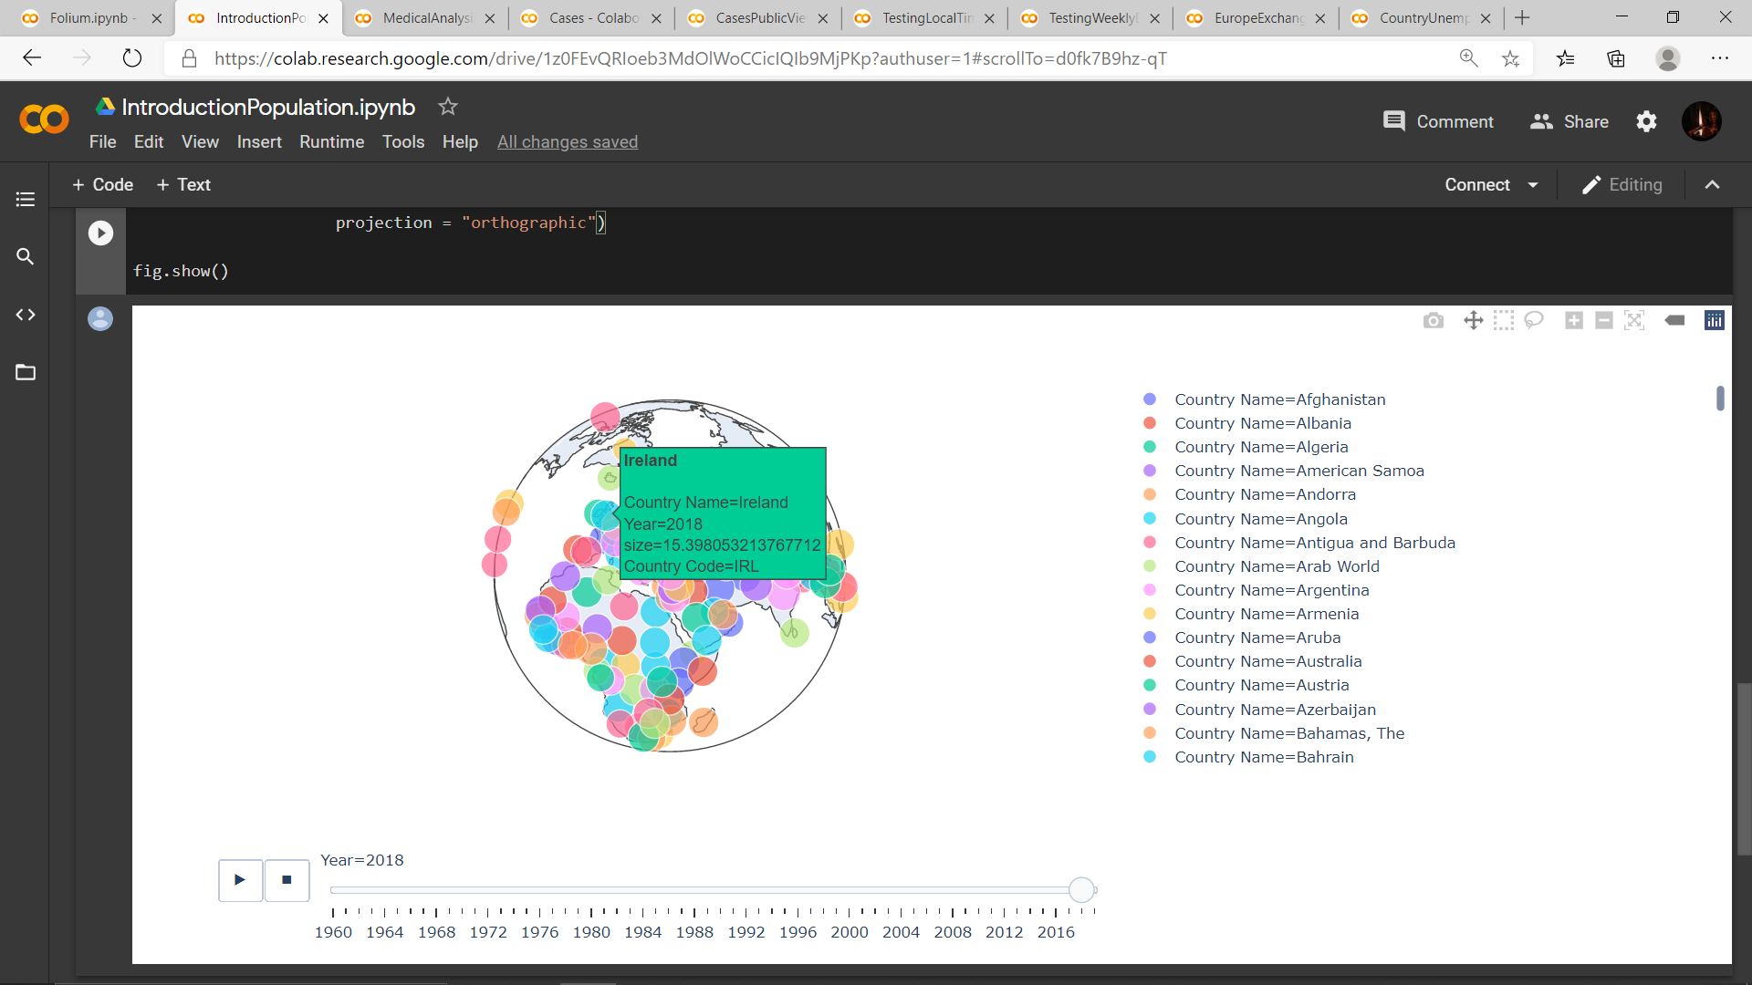

Figure 1: Dynamic scattered orthographic plot of world population (logarithmic of population) from 1960 to 2020

With acute respiratory distress syndrome (ARDS) with cold, fever, and loss of senses (taste and smell) are known to be the more profound symptoms of COVID-19 include fever, cough, fatigue, [breathing difficulties](https://en.wikipedia.org/wiki/Breathing_difficulties), and [loss of smell](https://en.wikipedia.org/wiki/Anosmia) and [taste](https://en.wikipedia.org/wiki/Ageusia). It was also been observed that in a longer span doctors have also witnessed damage to the heart and lungs as well as infection in body/ body parts. All of this can be comprised of an impact on the cognitive system, fatigue, and respiration.

Coming to the symptoms so, several means of spread has been observed namely, Close/ Direct contact (involving saliva and other bodily fluids and excretions). The exact route of transmission is rarely proven, but infection mainly happens when people are near each other for long enough, which is known as "close contact". It can spread as early as two days before infected persons show symptoms and from [asymptomatic](https://en.wikipedia.org/wiki/Asymptomatic) individuals. People remain infectious for up to ten days in moderate cases, and two weeks in severe cases. [Preventive measures](https://en.wikipedia.org/wiki/Pandemic_prevention) include [social distancing](https://en.wikipedia.org/wiki/Social_distancing), [quarantining](https://en.wikipedia.org/wiki/Quarantine), ventilation of indoor spaces, covering coughs and sneezes, [hand washing](https://en.wikipedia.org/wiki/Hand_washing), and keeping unwashed hands away from the face. The [use of face masks or coverings](https://en.wikipedia.org/wiki/Face_masks_during_the_COVID-19_pandemic) has been recommended in public settings to minimize the risk of transmissions.

From studies, it has been found that a sharp inclination death due to virus has been due to pollutant particles known as PM2.5, which has been consumed over years through the air. Researchers have analysed the data of deaths from the virus and on the tiny pollutant PM2.5 levels, and it was investigated that the pollutant was found in 98% of the U.S. population. Statistically, one microgram per m3 more concentration of PM2.5 in the air has resulted in a 15% higher rate of COVID-19 deaths.

The reason to all this is because these tiny pollutants penetrates deep into the human body which results in increasing complications of the COVID-19 patients with breathing problem, heart diseases, hypertension, and diabetes. It in turn weaken the immune system and causes inflammation in the lungs and respiratory tract and ultimately, makes the condition worst.

So, the idea is to visualize and decipher the influence of toxic air pollutant particles, ups and down in COVID-19 cases, the medical analysis and favourable treatment done in majorly in Ireland. Furthermore, bring out the impact of COVID-19 on the economies and in unemployment.

##### CHAPTER 2

**ANALYSIS**

For testing, a standard method known as [real-time reverse transcription-polymerase chain reaction](https://en.wikipedia.org/wiki/Real-time_reverse_transcription_polymerase_chain_reaction) has been into use. Results of respiratory samples through nasal swabs can reach from a couple of hours to two days. Moreover, blood tests can also be used with an immediate result. As of 4th April 2020, antibody tests are more accurate, but results take a couple of weeks to showcase any presence of the infecting virus.

Patients have even been tested COVID positive without the presence of any affecting symptoms of the virus in their body. A faster and risk-free alternative way has also been by collecting saliva samples using a sterile container when coughed. Along with testing in labs, a chest CT scan is another alternative for highly infected patients but not in chores.

**ABOUT THE DATA**

Air Pollution Dataset:

To behold and decipher the metamorphosis of air pollution before the inception of the pandemic as well as to make a prediction (after few years), a WORLDWIDE COVID-19 Dataset (2020) was extracted from Air Quality Open Data Platform of size 8, 23,002.

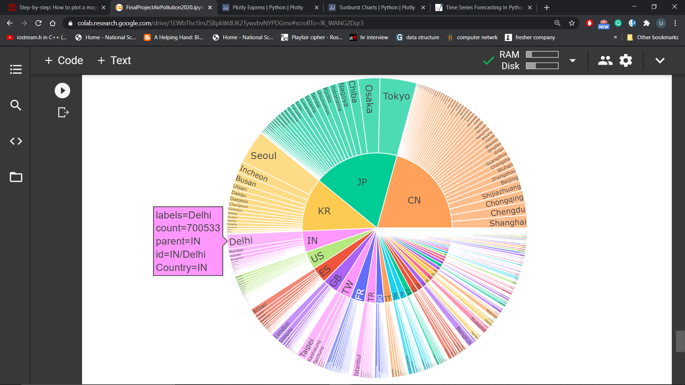

Figure 2: Total count of pollutants (CO, NO2, O3, PM1, PM10, PM2.5, SO2) in the Countries and in their Cities

Covid-19 Datasets:

To understand the inception, spread, and analysis of the pandemic, multiple COVID-19 datasets was extracted from the Government of Ireland data portal i.e., <https://data.gov.ie/dataset?theme=Health>**.**

|  |  |  |
| --- | --- | --- |
| DATA BASED ON | DATASET | DIMENSIONS |
|  |  |  |
| Air Pollution | waqi-covid19-airqualitydata-2020.csv | 823001 x 9 |
|  |  |  |
| COVID-19 | population_by_country_by_year.csv | 264 x 64 |
| cases_by_country_ireland.csv | 595 x 10 |
| ICUBIHistoricTimelinePublicView.csv | 217 x 4 |
| COVIDStatisticsProfileHPSCIrelandOpenData.csv | 252 x 38 |
| LaboratoryLocalTimeSeriesHistoricView.csv | 227 x 11 |
| Weekly_testing_data_europe.csv | 1011 x 9 |
| unemployment_by_country_by_year.csv | 264 x 65 |
| Euro_exchange_rates.csv | 205 x 37 |

Table 1: List of details of datasets used in the project

This project will majorly focus on the statistics and the impact of COVID-19 on Ireland. So, understanding the dynamic of COVID-19 is paramount and thus, to decipher a plausible virtuoso this section is bifurcated into four sub-sections concerning the data provided. These sections are namely,

* Effect of Air Pollutants
* Cases Investigation
* Medical Strategies
* Testing Interpretations

**EFFECT OF AIR POLLUTANTS**

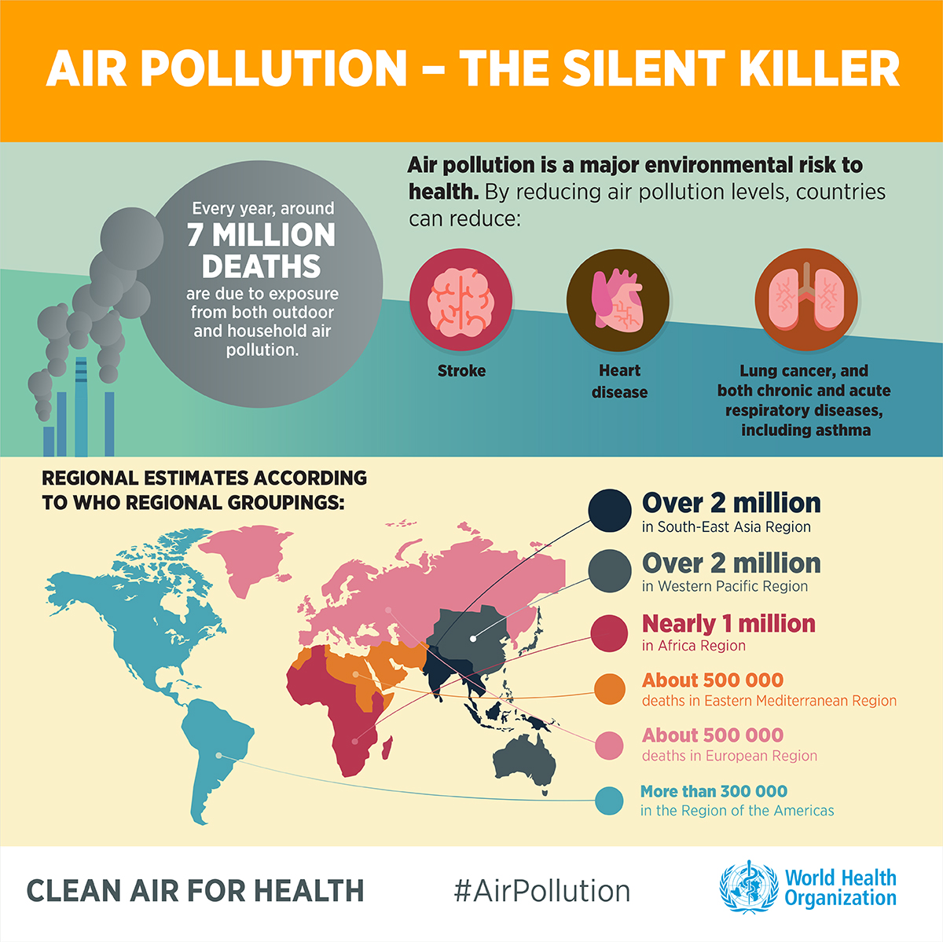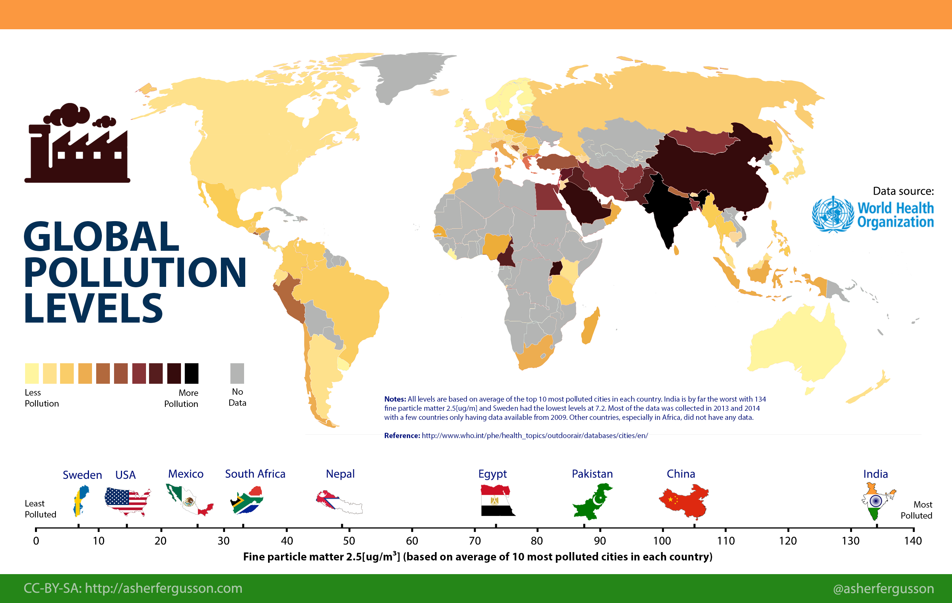

Figure 3 and 4: Statistical Interpretations on Air Pollution

As the novel coronavirus tears around the world, it is exploiting our biggest weaknesses from creaking health care systems to extreme social inequality. Its relationship with one pervasive and neglected problem, however, is more tangled as the air pollution has intensified the pandemic.

The fine particles penetrate deep into the body, promoting hypertension, heart disease, breathing trouble, and diabetes, all of which increase complications in coronavirus patients.

The particles also weaken the immune system and fuel inflammation in the lungs and respiratory tract, adding to the risk both of getting COVID-19 and of having severe symptoms. From the air pollution data extracted to apprehend the behaviour of pollutants namely, S02, NO2, CO, PM10, PM2.5, O3 and PM1.

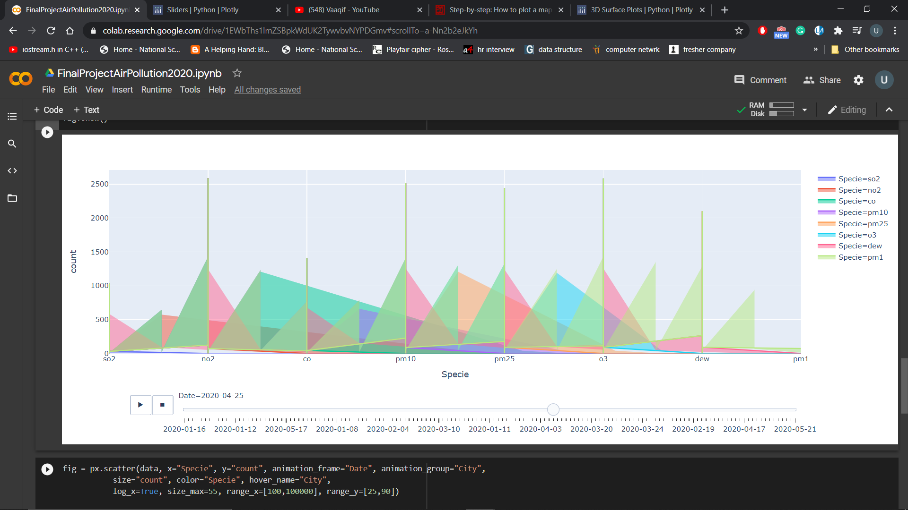Figure 5: Dynamic plot representing the metamorphosis on the amount of air pollutants from January 2020 to May 2020

**CASES INVESTIGATION**

It has been complication to collect the actual numbers of affected people but from the data obtained it has been found that the total confirmed cases in Ireland have jumped from 68 cases in March 2020 to the peak of 140 (approx.) in April and with gradual declination to as low as only 7 total confirmed cases by September end (Figure 2). With effective treatments and procedures, admitted cases and discharged cases are moved on simultaneously to witness a gradual decrease in cases in April 2020.

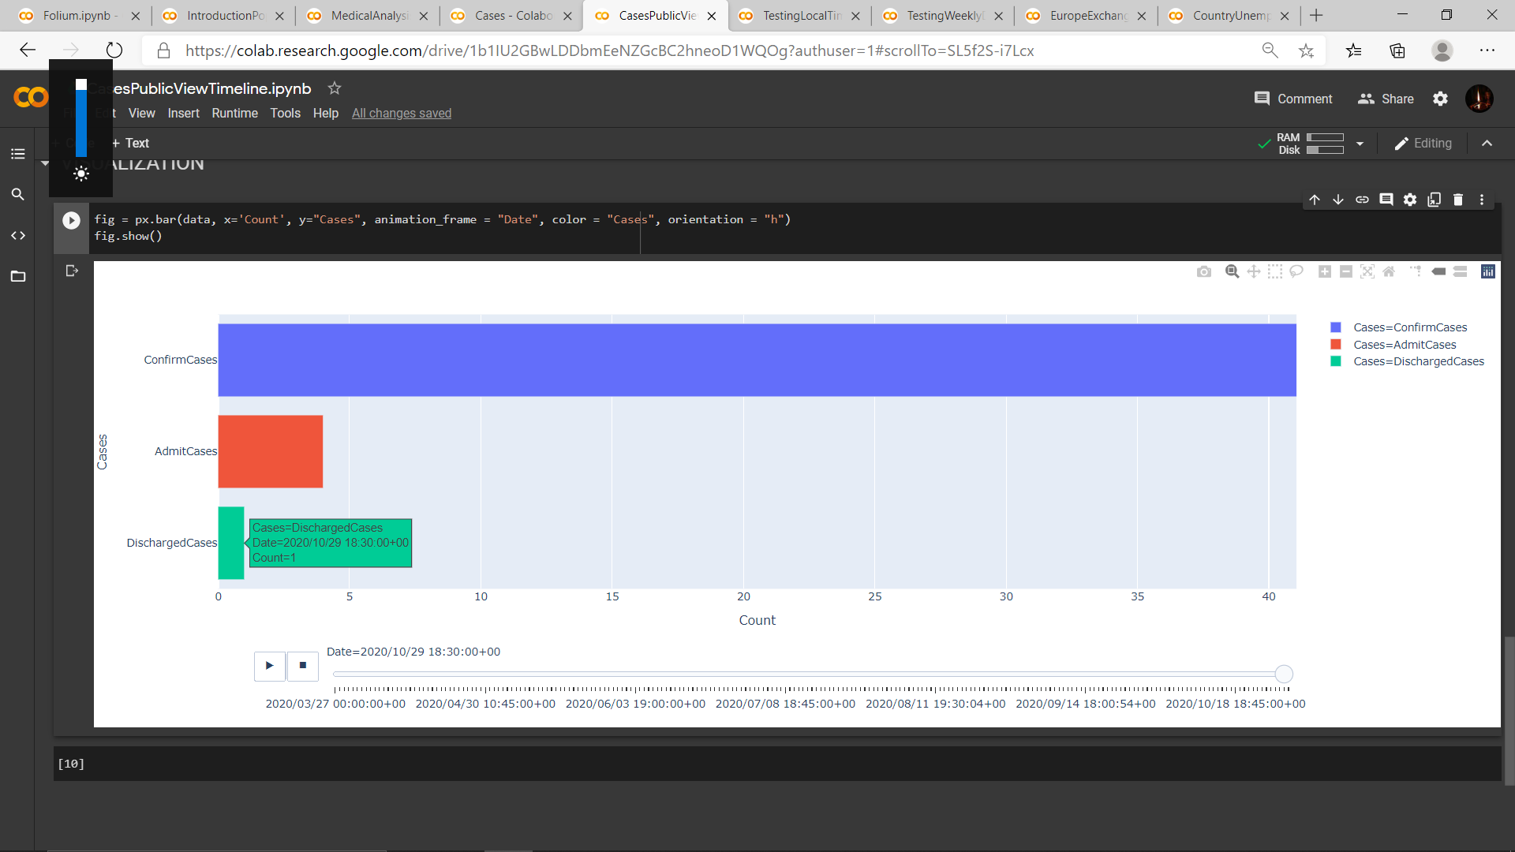

Figure 6: Bar-plot for different cases (i.e., Confirm Cases, Admit Cases and Discharged Cases) in Ireland from last March 2020 to mid-September 2020

The following map (Figure 3) shows the number of cases in different plotted regions of Ireland using the Foursquare API and Folium. All the different Counties of Ireland are represented in the map below with a number of cases and the label in their respective region.

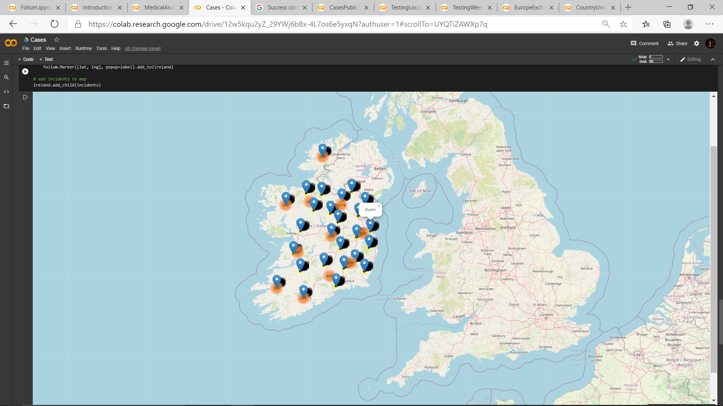

Figure 7: Folium map for COVID cases in Ireland over 7 months

A more detailed analysis of the transition of the case over the course of 7 months on daily basis can be investigated from the below bar-plot (Figure 4). The plot shows the until 3rd April, not so prominent cases were witnessed but just a day after they have inclined all over Ireland and especially in Dublin. Within a span of just a month, the cases have massively increased from ~470 to 10,000+. Though after a couple of months rise slowly, September has been the most affected for Dublin, as cases moved from 14,000 to over 20,000 by the month-end. Apart from Dublin having exceptionally high cases followed by Cork, counties like Leitrim, Sligo, and Carlow have been the least affected ones.

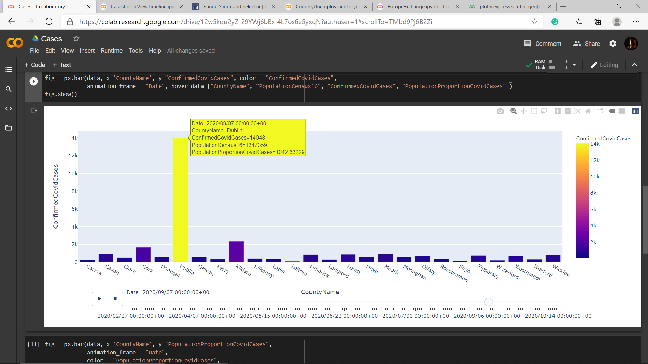

Figure 8: Confirm COVID cases in different county in Ireland from end January 2020 to early September 2020

The plot above gave another picture of the confirmed cases where all the Counties did not seem much affected by COVID. But here is another picture to decipher to propel the proportion of each County affected by the virus from March to September.

Unlike the above plot, the below plot (Figure 5) clearly shows a clear COVID-19 influenced scenario in different regions of Ireland. Though the rate of increase has been unexpectedly higher for Cavan and Westmeath the most affected counties in Ireland are Cavan, Dublin, Kildare, and Monaghan while Waterford, Wexford, and Galway are the least.

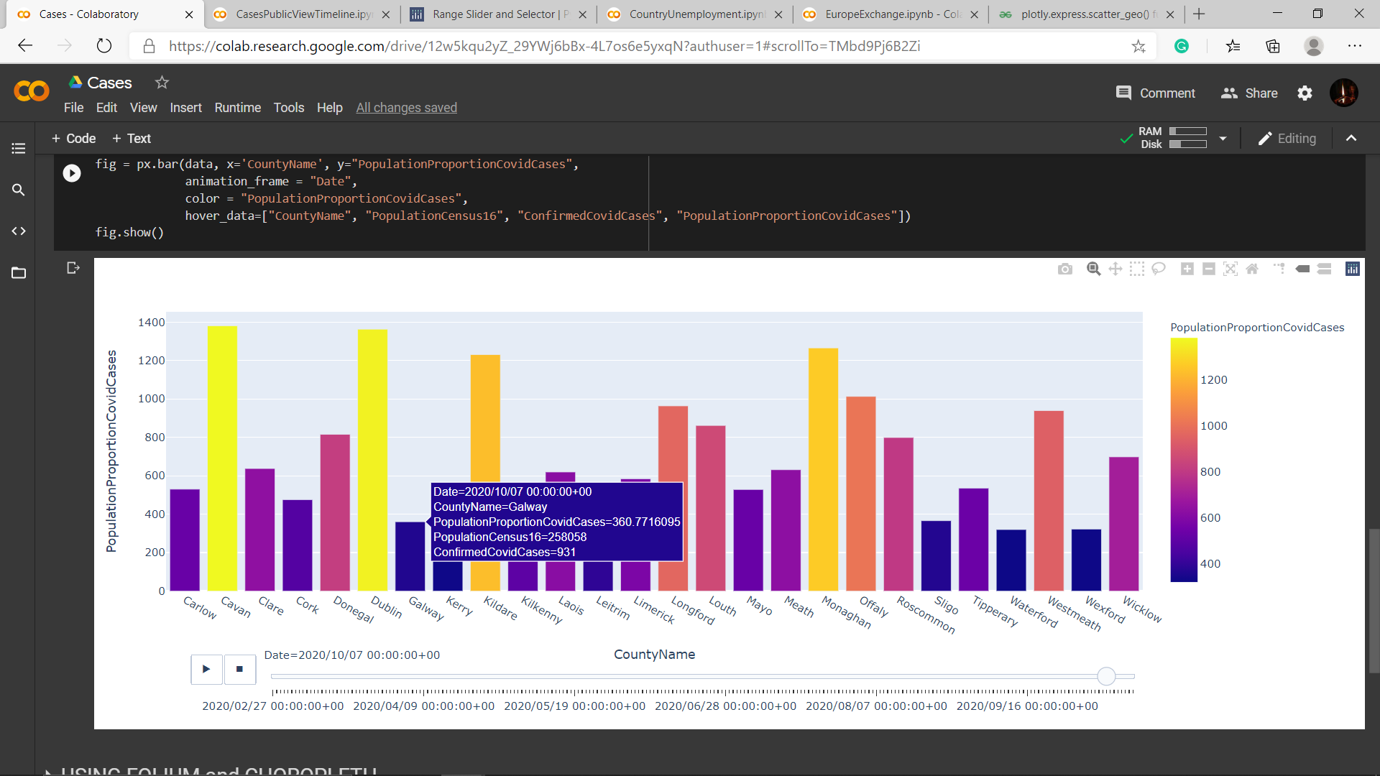

Figure 9: Proportion of population affected with COVID in different Ireland County from end January 2020 to early September 2020

**MEDICAL STRATEGIES**

Without effective treatment measures, alternatives are required to slow or decline the impact of the pandemic apex and flattening the [curve](https://en.wikipedia.org/wiki/Epidemic_curve) of infection.

The impact of the virus has been witnessed in stages i.e., close contact, traveling abroad, and community transfer. Preventive measures are found to be sanitizing, homestay, wearing masks, maintaining social distancing, and avoid gathering. Maintaining a healthy lifestyle and hygiene, use of handkerchief or tissue while sneezing or coughing are the prominent measures that can be taken into notice.

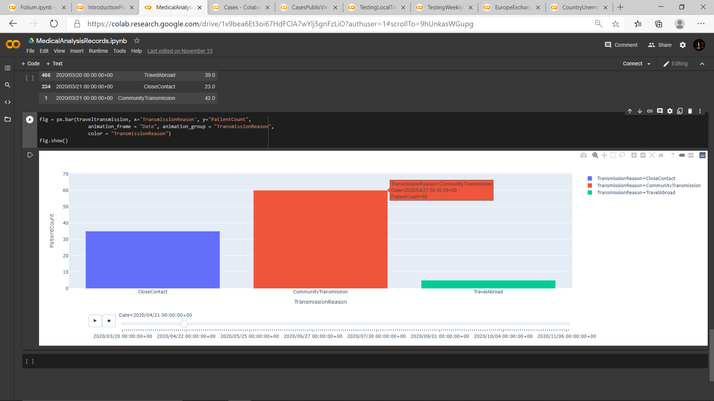

Figure 10: An important aspect of COVID is the pattern of spread of disease in different phases i.e., Travel Abroad, Close Contact and Community Transmission.

From the data and the above plot (Figure 6) the people living in Ireland have been least affected by traveling abroad while from June to September the most cases of this pandemic were witnessed due to close contact.

Coming on to the influence in different age-groups so, the impact of the virus propelled with the influence within the age-group of 25-54. But with slower and lower immunity towards fitting the virus in adults, people aged 65+ have been the most affected ones while lowest cases were observed for kids and teenagers. As a counteraction towards the virus, antibodies started to build in some people naturally, while in some they were given externally to strengthen the immune system and dominate over the virus. By now, many people without any signs of the pandemic virus has been producing antibodies within their body. A more detailed impact on different age criteria can be analysed from the below plot (Figure 7).

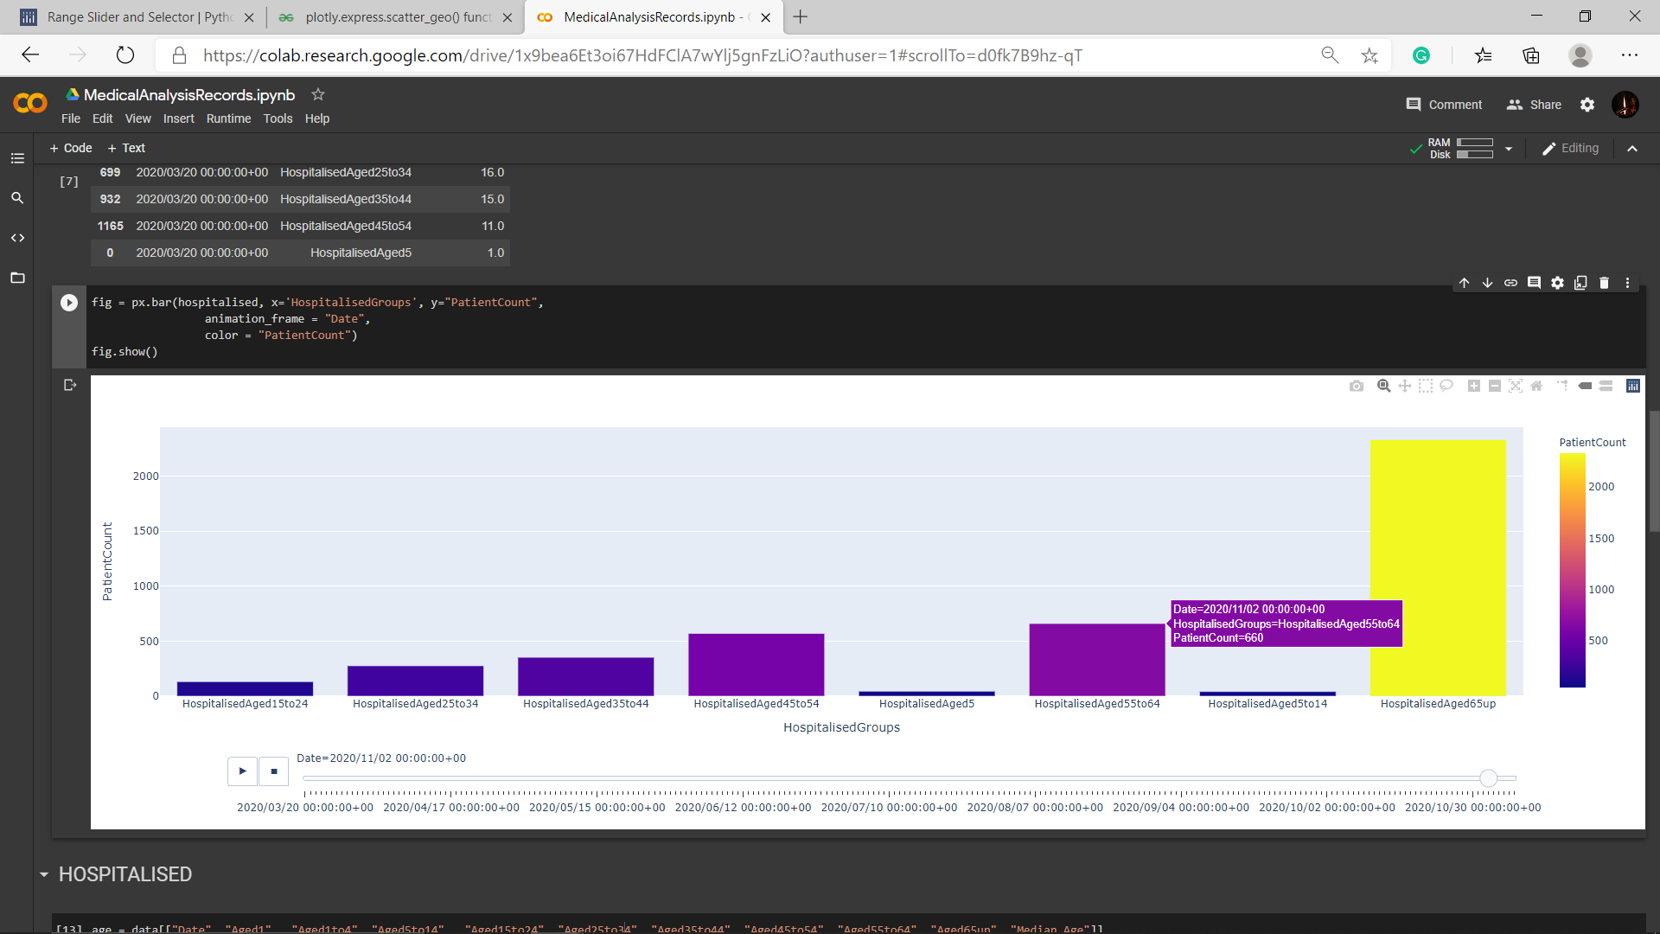

Figure 11: Different age group of total citizens affected from COVID from March 2020 to September 2020

**TESTING INTERPRETATIONS**

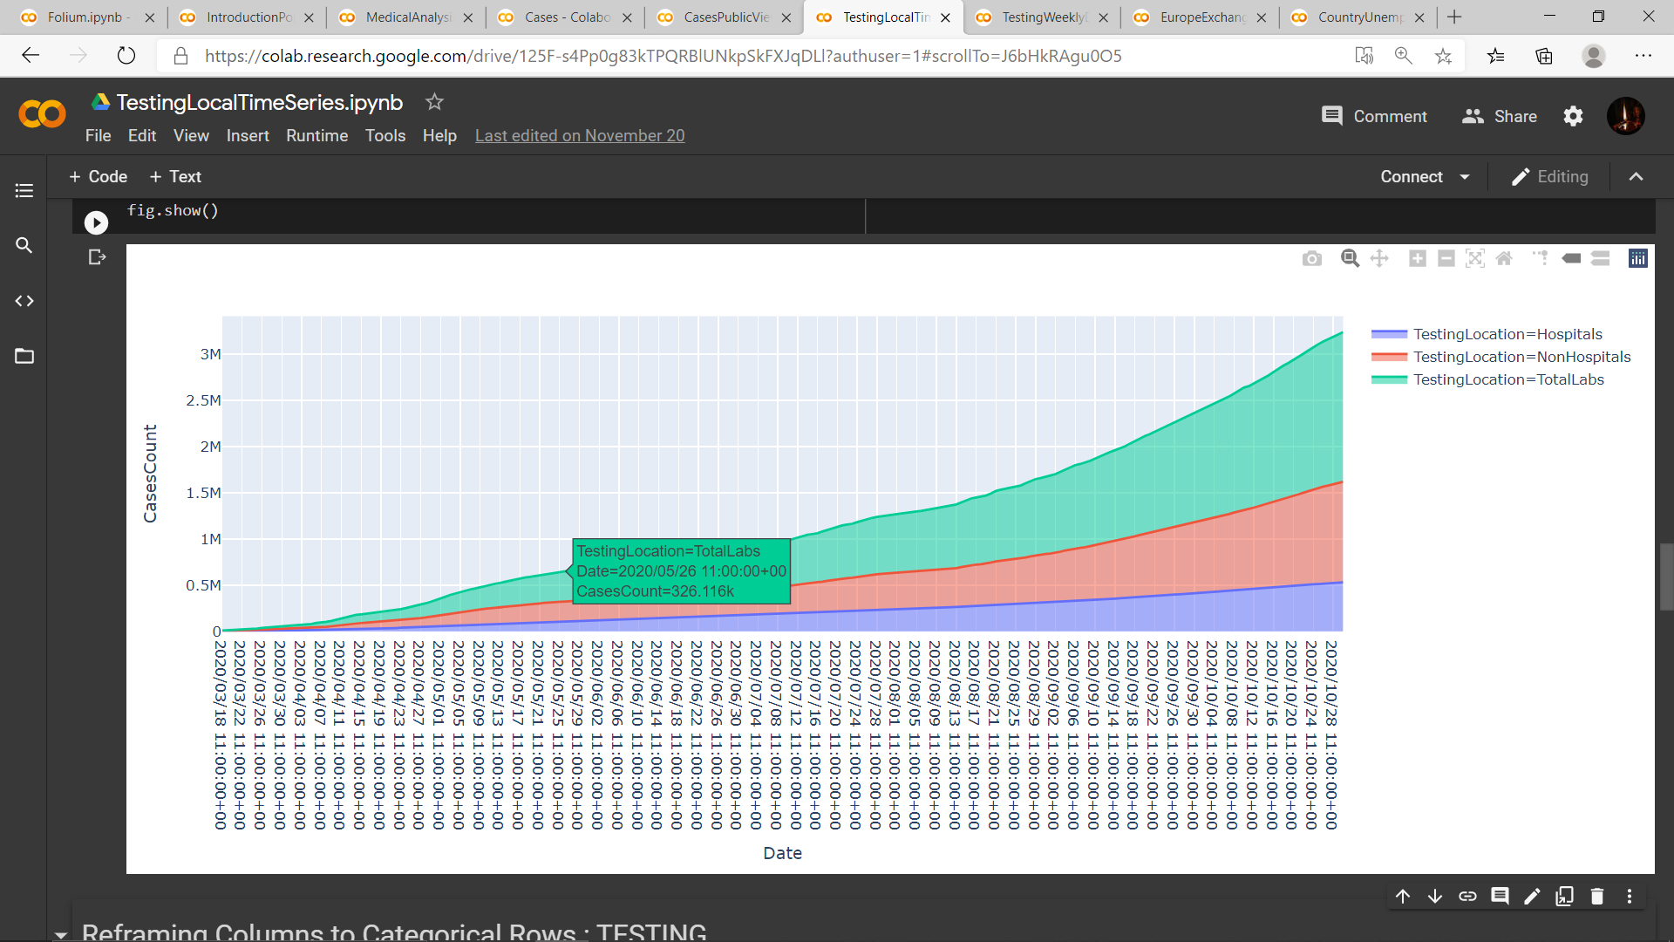

Figure 12: Total number of testing performed in different labs i.e., in Hospital Labs and in Non-Hospital Labs from January 2020 to September 2020.

With the increase in cases and harm on the people with diverse symptoms - even some without any symptoms - it has been paramount to find a hold on the radical besiegement of the impact. Thus, the relevant testing and experiments were performed in numerous labs, some in Hospitals while more Non-Hospitals Labs (Figure 12). And the related statistics can be seen from the above plot for the course of March to September 2020.

The rising cases in countries have been unexpected but the testing was held strong. Even after and intensive impact, many countries have show praise-worthy efforts with testing in manifolds (Figure 13). Ireland has been a low impacted country, with requisite amount of testing done and negligible COVID-19 positive cases, comparatively.

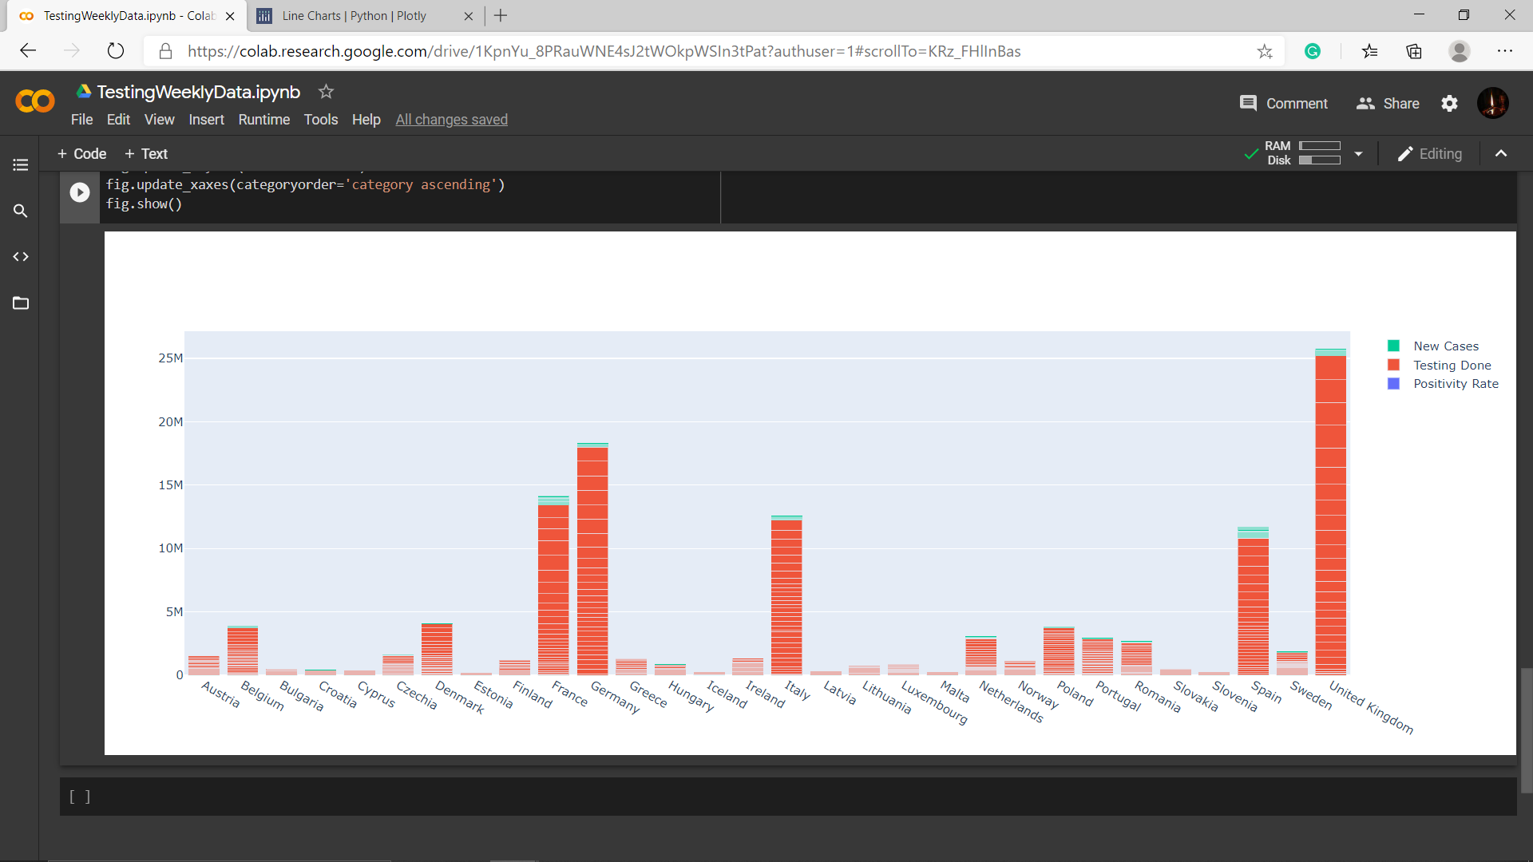

Figure 13: Response of the countries to the new cases and the tests performed.

**CHAPTER 3**

**RESULTS AND CONCLUSION**

The results of the ongoing pandemic and from the above analyses is the devastating impact on the economy and employment. With lockdowns being imposed all over the globe, the market was shut down resulting in altering of the value of Euros and other currencies. From the below plot (Figure 13), it can be witnessed through the span from March 2020 to September 2020 with respect to Euros, the value of Indonesian Rupiah rises from ~15540.42 to ~17317.86, the value of Indian Rupees lifted from ~80.00 to ~86.19 and South Korean won moved up from ~1300.32 to ~1390.72 to ~1341.16. While the exchange rate with rest of the countries has been with minimal change.

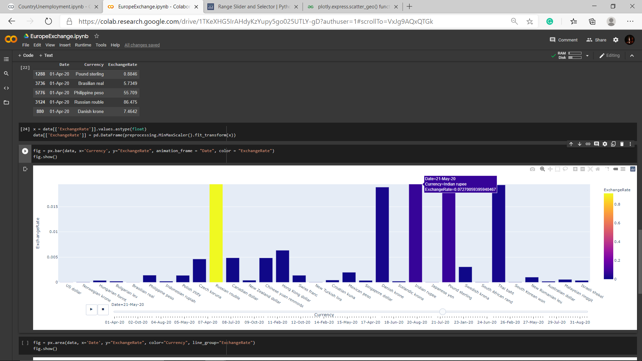

Figure 14: Value of Euros vs other currencies from Jan 2020 to mid-October 2020

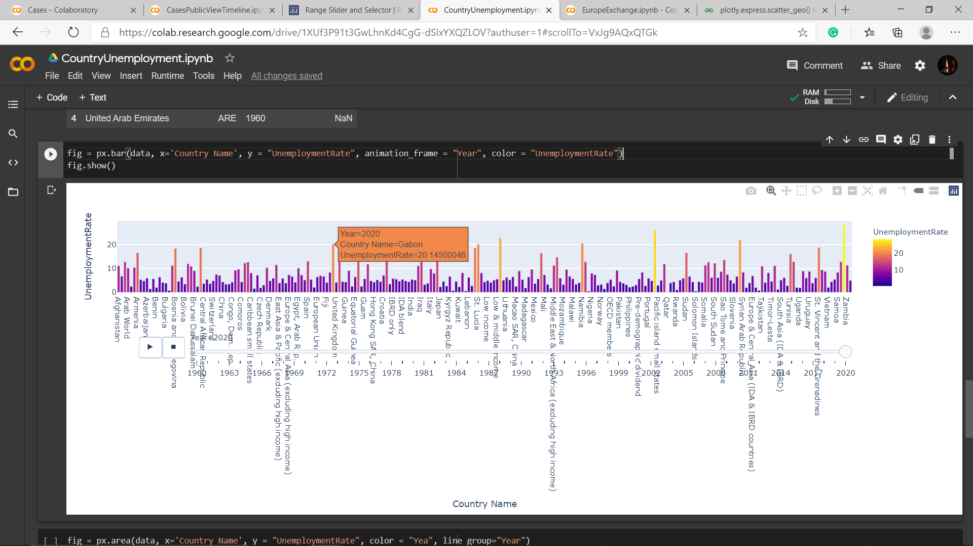

Figure 15: Unemployment in the world from 1960 to 2020

With the impact on the economies coming up, the unexpected bump by the employment sector. With people getting tested positive and economy on verge, the companies had to fire employees to a massive scale as can be seen below (Figure 14). It was observed that South Africa (28.47%) and West Bank and Gaza (26%) had highest unemployment rate while Qatar with the lowest unemployment rate of 0.082% followed by Niger, Solomon Islands, Lao PDR and Cambodia with rate between ~0.40-0.70%.

**REFERENCES**

1. ["Transmission of COVID-19"](https://www.ecdc.europa.eu/en/covid-19/latest-evidence/transmission). European Centre for Disease Prevention and Control. Retrieved 6 December 2020.
2. [**^**](https://en.wikipedia.org/wiki/Coronavirus_disease_2019#cite_ref-10) Ye Q, Wang B, Mao J (June 2020). ["The pathogenesis and treatment of the 'Cytokine Storm' in COVID-19"](https://www.ncbi.nlm.nih.gov/pmc/articles/PMC7194613). The Journal of Infection. **80** (6): 607–613. [doi](https://en.wikipedia.org/wiki/Doi_(identifier)):[10.1016/j.jinf.2020.03.037](https://doi.org/10.1016/j.jinf.2020.03.037). [PMC](https://en.wikipedia.org/wiki/PMC_(identifier)) [7194613](https://www.ncbi.nlm.nih.gov/pmc/articles/PMC7194613). [PMID](https://en.wikipedia.org/wiki/PMID_(identifier)) [32283152](https://pubmed.ncbi.nlm.nih.gov/32283152).
3. [**^**](https://en.wikipedia.org/wiki/Coronavirus_disease_2019#cite_ref-yelin_11-0) Yelin D, Wirtheim E, Vetter P, Kalil AC, Bruchfeld J, Runold M, et al. (September 2020). ["Long-term consequences of COVID-19: research needs"](https://www.ncbi.nlm.nih.gov/pmc/articles/PMC7462626). The Lancet. Infectious Diseases. **20** (10): 1115–1117. [doi](https://en.wikipedia.org/wiki/Doi_(identifier)):[10.1016/S1473-3099(20)30701-5](https://doi.org/10.1016/S1473-3099(20)30701-5). [PMC](https://en.wikipedia.org/wiki/PMC_(identifier)) [7462626](https://www.ncbi.nlm.nih.gov/pmc/articles/PMC7462626). [PMID](https://en.wikipedia.org/wiki/PMID_(identifier)) [32888409](https://pubmed.ncbi.nlm.nih.gov/32888409).
4. [**^**](https://en.wikipedia.org/wiki/Coronavirus_disease_2019#cite_ref-hmri_12-0) ["What are the long-term symptoms of COVID-19?"](https://hmri.org.au/news-article/what-are-long-term-symptoms-covid-19). HMRI. 4 August 2020. Retrieved 8 September 2020.
5. [**^**](https://en.wikipedia.org/wiki/Coronavirus_disease_2019#cite_ref-mayo_13-0) ["COVID-19 (coronavirus): Long-term effects"](https://www.mayoclinic.org/diseases-conditions/coronavirus/in-depth/coronavirus-long-term-effects/art-20490351). Mayo Clinic. 18 August 2020. Retrieved 8 September 2020.
6. [**^**](https://en.wikipedia.org/wiki/Coronavirus_disease_2019#cite_ref-racgp_14-0) ["What are the long-term health risks following COVID-19?"](https://www1.racgp.org.au/newsgp/clinical/what-are-the-long-term-health-risks-post-covid-19). NewsGP. Royal Australian College of General Practitioners (RACGP). 24 June 2020. Retrieved 8 September 2020.
7. [**^**](https://en.wikipedia.org/wiki/Coronavirus_disease_2019#cite_ref-15) CDC. ["Coronavirus Disease 2019 (COVID-19)"](https://www.cdc.gov/coronavirus/2019-ncov/php/contact-tracing/contact-tracing-plan/appendix.html#contact). Centers for Disease Control and Prevention. Retrieved 22 October 2020.
8. [**^**](https://en.wikipedia.org/wiki/Coronavirus_disease_2019#cite_ref-16) ["Quarantine for coronavirus (COVID-19)"](https://www.health.gov.au/news/health-alerts/novel-coronavirus-2019-ncov-health-alert/how-to-protect-yourself-and-others-from-coronavirus-covid-19/quarantine-for-coronavirus-covid-19#what-is-a-close-contact). Australian Government Department of Health. Retrieved 25 September 2020.
9. [**^**](https://en.wikipedia.org/wiki/Coronavirus_disease_2019#cite_ref-CDCTrans_17-0) ["How COVID-19 Spreads"](https://www.cdc.gov/coronavirus/2019-ncov/prevent-getting-sick/how-covid-spreads.html). U.S. *[Centers for Disease Control and Prevention](https://en.wikipedia.org/wiki/Centers_for_Disease_Control_and_Prevention)* (CDC). 18 September 2020. [Archived](https://web.archive.org/web/20200919224920/https://www.cdc.gov/coronavirus/2019-ncov/prevent-getting-sick/how-covid-spreads.html?CDC_AA_refVal=https://www.cdc.gov/coronavirus/2019-ncov/prepare/transmission.html) from the original on 19 September 2020. Retrieved 20 September 2020.
10. [**^**](https://en.wikipedia.org/wiki/Coronavirus_disease_2019#cite_ref-19) ["Coronavirus disease (COVID-19): How is it transmitted?"](https://www.who.int/news-room/q-a-detail/coronavirus-disease-covid-19-how-is-it-transmitted). www.who.int. Retrieved 6 December 2020.
11. ^ [Jump up to:***a***](https://en.wikipedia.org/wiki/Coronavirus_disease_2019#cite_ref-:2_20-0) [***b***](https://en.wikipedia.org/wiki/Coronavirus_disease_2019#cite_ref-:2_20-1) CDC (11 February 2020). ["Coronavirus Disease 2019 (COVID-19)"](https://www.cdc.gov/coronavirus/2019-ncov/faq.html). Centers for Disease Control and Prevention. Retrieved 6 December 2020.
12. ["ACR Recommendations for the use of Chest Radiography and Computed Tomography (CT) for Suspected COVID-19 Infection"](https://www.acr.org/Advocacy-and-Economics/ACR-Position-Statements/Recommendations-for-Chest-Radiography-and-CT-for-Suspected-COVID19-Infection). American College of Radiology. 22 March 2020. [Archived](https://web.archive.org/web/20200328055813/https://www.acr.org/Advocacy-and-Economics/ACR-Position-Statements/Recommendations-for-Chest-Radiography-and-CT-for-Suspected-COVID19-Infection) from the original on 28 March 2020.
13. [**^**](https://en.wikipedia.org/wiki/Coronavirus_disease_2019#cite_ref-102) Pormohammad A, Ghorbani S, Khatami A, Razizadeh MH, Alborzi E, Zarei M, et al. (October 2020). ["Comparison of influenza type A and B with COVID-19: A global systematic review and meta-analysis on clinical, laboratory and radiographic findings"](https://www.ncbi.nlm.nih.gov/pmc/articles/PMC7646051). Reviews in Medical Virology: e2179. [doi](https://en.wikipedia.org/wiki/Doi_(identifier)):[10.1002/rmv.2179](https://doi.org/10.1002/rmv.2179). [PMC](https://en.wikipedia.org/wiki/PMC_(identifier)) [7646051](https://www.ncbi.nlm.nih.gov/pmc/articles/PMC7646051). [PMID](https://en.wikipedia.org/wiki/PMID_(identifier)) [33035373](https://pubmed.ncbi.nlm.nih.gov/33035373). [S2CID](https://en.wikipedia.org/wiki/S2CID_(identifier)) [222255245](https://api.semanticscholar.org/CorpusID:222255245).
14. [**^**](https://en.wikipedia.org/wiki/Coronavirus_disease_2019#cite_ref-103) Lee EY, Ng MY, Khong PL (April 2020). ["COVID-19 pneumonia: what has CT taught us?"](https://www.ncbi.nlm.nih.gov/pmc/articles/PMC7128449). The Lancet. Infectious Diseases. **20** (4): 384–385. [doi](https://en.wikipedia.org/wiki/Doi_(identifier)):[10.1016/S1473-3099(20)30134-1](https://doi.org/10.1016/S1473-3099(20)30134-1). [PMC](https://en.wikipedia.org/wiki/PMC_(identifier)) [7128449](https://www.ncbi.nlm.nih.gov/pmc/articles/PMC7128449). [PMID](https://en.wikipedia.org/wiki/PMID_(identifier)) [32105641](https://pubmed.ncbi.nlm.nih.gov/32105641).
15. ^ [Jump up to:***a***](https://en.wikipedia.org/wiki/Coronavirus_disease_2019#cite_ref-AJR_104-0) [***b***](https://en.wikipedia.org/wiki/Coronavirus_disease_2019#cite_ref-AJR_104-1) Li Y, Xia L (March 2020). "Coronavirus Disease 2019 (COVID-19): Role of Chest CT in Diagnosis and Management". AJR. American Journal of Roentgenology. **214** (6): 1280–1286. [doi](https://en.wikipedia.org/wiki/Doi_(identifier)):[10.2214/AJR.20.22954](https://doi.org/10.2214/AJR.20.22954). [PMID](https://en.wikipedia.org/wiki/PMID_(identifier)) [32130038](https://pubmed.ncbi.nlm.nih.gov/32130038). [S2CID](https://en.wikipedia.org/wiki/S2CID_(identifier)) [212416282](https://api.semanticscholar.org/CorpusID:212416282).
16. [**^**](https://en.wikipedia.org/wiki/Coronavirus_disease_2019#cite_ref-Cx70C_105-0) ["COVID-19 Database"](https://www.sirm.org/category/senza-categoria/covid-19/). Società Italiana di Radiologia Medica e Interventistica (in Italian). Retrieved 11 March 2020.
17. [**^**](https://en.wikipedia.org/wiki/Coronavirus_disease_2019#cite_ref-ICD10_2019_U07p2_106-0) ["ICD-10 Version:2019"](https://icd.who.int/browse10/2019/en#/U07.1). [*World Health Organization*](https://en.wikipedia.org/wiki/World_Health_Organization). 2019. [Archived](https://archive.today/20200331004754/https://icd.who.int/browse10/2019/en%23/U07.1) from the original on 31 March 2020. Retrieved 31 March2020. U07.2 – COVID-19, virus not identified – COVID-19 NOS – Use this code when COVID-19 is diagnosed clinically or epidemiologically but laboratory testing is inconclusive or not available. Use additional code, if desired, to identify pneumonia or other manifestations
18. [**^**](https://en.wikipedia.org/wiki/Coronavirus_disease_2019#cite_ref-107) Giani M, Seminati D, Lucchini A, Foti G, Pagni F (May 2020). ["Exuberant Plasmocytosis in Bronchoalveolar Lavage Specimen of the First Patient Requiring Extracorporeal Membrane Oxygenation for SARS-CoV-2 in Europe"](https://www.ncbi.nlm.nih.gov/pmc/articles/PMC7118681). Journal of Thoracic Oncology. **15** (5): e65–e66. [doi](https://en.wikipedia.org/wiki/Doi_(identifier)):[10.1016/j.jtho.2020.03.008](https://doi.org/10.1016/j.jtho.2020.03.008). [PMC](https://en.wikipedia.org/wiki/PMC_(identifier)) [7118681](https://www.ncbi.nlm.nih.gov/pmc/articles/PMC7118681). [PMID](https://en.wikipedia.org/wiki/PMID_(identifier)) [32194247](https://pubmed.ncbi.nlm.nih.gov/32194247).
19. [**^**](https://en.wikipedia.org/wiki/Coronavirus_disease_2019#cite_ref-108) Lillicrap D (April 2020). ["Disseminated intravascular coagulation in patients with 2019-nCoV pneumonia"](https://www.ncbi.nlm.nih.gov/pmc/articles/PMC7166410). Journal of Thrombosis and Haemostasis. **18** (4): 786–787. [doi](https://en.wikipedia.org/wiki/Doi_(identifier)):[10.1111/jth.14781](https://doi.org/10.1111/jth.14781). [PMC](https://en.wikipedia.org/wiki/PMC_(identifier)) [7166410](https://www.ncbi.nlm.nih.gov/pmc/articles/PMC7166410). [PMID](https://en.wikipedia.org/wiki/PMID_(identifier)) [32212240](https://pubmed.ncbi.nlm.nih.gov/32212240).
20. [**^**](https://en.wikipedia.org/wiki/Coronavirus_disease_2019#cite_ref-109) Mitra A, Dwyre DM, Schivo M, Thompson GR, Cohen SH, Ku N, Graff JP (March 2020). ["Leukoerythroblastic reaction in a patient with COVID-19 infection"](https://www.ncbi.nlm.nih.gov/pmc/articles/PMC7228283). American Journal of Hematology. **95**(8): 999–1000. [doi](https://en.wikipedia.org/wiki/Doi_(identifier)):[10.1002/ajh.25793](https://doi.org/10.1002/ajh.25793). [PMC](https://en.wikipedia.org/wiki/PMC_(identifier)) [7228283](https://www.ncbi.nlm.nih.gov/pmc/articles/PMC7228283). [PMID](https://en.wikipedia.org/wiki/PMID_(identifier)) [32212392](https://pubmed.ncbi.nlm.nih.gov/32212392).
21. [**^**](https://en.wikipedia.org/wiki/Coronavirus_disease_2019#cite_ref-Science_20200515_110-0) Maier BF, Brockmann D (May 2020). ["Effective containment explains subexponential growth in recent confirmed COVID-19 cases in China"](https://www.ncbi.nlm.nih.gov/pmc/articles/PMC7164388). Science. **368** (6492): 742–746. [Bibcode](https://en.wikipedia.org/wiki/Bibcode_(identifier)):[2020Sci...368..742M](https://ui.adsabs.harvard.edu/abs/2020Sci...368..742M). [doi](https://en.wikipedia.org/wiki/Doi_(identifier)):[10.1126/science.abb4557](https://doi.org/10.1126/science.abb4557). [PMC](https://en.wikipedia.org/wiki/PMC_(identifier)) [7164388](https://www.ncbi.nlm.nih.gov/pmc/articles/PMC7164388). [PMID](https://en.wikipedia.org/wiki/PMID_(identifier)) [32269067](https://pubmed.ncbi.nlm.nih.gov/32269067). ("...initial exponential growth expected for an unconstrained outbreak.")
22. [**^**](https://en.wikipedia.org/wiki/Coronavirus_disease_2019#cite_ref-ukgov12-2_111-0) ["UK medicines regulator gives approval for first UK COVID-19 vaccine"](https://www.gov.uk/government/news/uk-medicines-regulator-gives-approval-for-first-uk-covid-19-vaccine). Medicines and Healthcare Products Regulatory Agency, Government of the UK. 2 December 2020. Retrieved 2 December2020.
23. [**^**](https://en.wikipedia.org/wiki/Coronavirus_disease_2019#cite_ref-mueller_112-0) Benjamin Mueller (2 December 2020). ["U.K. Approves Pfizer Coronavirus Vaccine, a First in the West"](https://www.nytimes.com/2020/12/02/world/europe/pfizer-coronavirus-vaccine-approved-uk.html). The New York Times. Retrieved 2 December 2020.
24. [**^**](https://en.wikipedia.org/wiki/Coronavirus_disease_2019#cite_ref-NIHGuidelines2020_113-0) ["COVID-19 Treatment Guidelines"](https://covid19treatmentguidelines.nih.gov/introduction/). www.nih.gov. National Institutes of Health. Retrieved 21 April 2020.
25. ^ [Jump up to:***a***](https://en.wikipedia.org/wiki/Coronavirus_disease_2019#cite_ref-Sanders20202_114-0) [***b***](https://en.wikipedia.org/wiki/Coronavirus_disease_2019#cite_ref-Sanders20202_114-1) [***c***](https://en.wikipedia.org/wiki/Coronavirus_disease_2019#cite_ref-Sanders20202_114-2) [***d***](https://en.wikipedia.org/wiki/Coronavirus_disease_2019#cite_ref-Sanders20202_114-3) Sanders JM, Monogue ML, Jodlowski TZ, Cutrell JB (April 2020). ["Pharmacologic Treatments for Coronavirus Disease 2019 (COVID-19): A Review"](https://doi.org/10.1001/jama.2020.6019). JAMA. **323** (18): 1824–1836. [doi](https://en.wikipedia.org/wiki/Doi_(identifier)):[10.1001/jama.2020.6019](https://doi.org/10.1001/jama.2020.6019). [PMID](https://en.wikipedia.org/wiki/PMID_(identifier)) [32282022](https://pubmed.ncbi.nlm.nih.gov/32282022).
26. ^ [Jump up to:***a***](https://en.wikipedia.org/wiki/Coronavirus_disease_2019#cite_ref-Lancet2020Flatten_115-0) [***b***](https://en.wikipedia.org/wiki/Coronavirus_disease_2019#cite_ref-Lancet2020Flatten_115-1) Anderson RM, Heesterbeek H, Klinkenberg D, Hollingsworth TD (March 2020). ["How will country-based mitigation measures influence the course of the COVID-19 epidemic?"](https://www.ncbi.nlm.nih.gov/pmc/articles/PMC7158572). Lancet. **395**(10228): 931–934. [doi](https://en.wikipedia.org/wiki/Doi_(identifier)):[10.1016/S0140-6736(20)30567-5](https://doi.org/10.1016/S0140-6736(20)30567-5). [PMC](https://en.wikipedia.org/wiki/PMC_(identifier)) [7158572](https://www.ncbi.nlm.nih.gov/pmc/articles/PMC7158572). [PMID](https://en.wikipedia.org/wiki/PMID_(identifier)) [32164834](https://pubmed.ncbi.nlm.nih.gov/32164834). A key issue for epidemiologists is helping policy makers decide the main objectives of mitigation—e.g. minimising morbidity and associated mortality, avoiding an epidemic peak that overwhelms health-care services, keeping the effects on the economy within manageable levels, and flattening the epidemic curve to wait for vaccine development and manufacture on scale and antiviral drug therapies.
27. [**^**](https://en.wikipedia.org/wiki/Coronavirus_disease_2019#cite_ref-Wiles_116-0) Wiles S (14 March 2020). ["After 'Flatten the Curve', we must now 'Stop the Spread'. Here's what that means"](https://thespinoff.co.nz/society/14-03-2020/after-flatten-the-curve-we-must-now-stop-the-spread-heres-what-that-means/). The Spinoff. [Archived](https://web.archive.org/web/20200326232315/https://thespinoff.co.nz/society/14-03-2020/after-flatten-the-curve-we-must-now-stop-the-spread-heres-what-that-means/) from the original on 26 March 2020. Retrieved 13 March2020.
28. [**^**](https://en.wikipedia.org/wiki/Coronavirus_disease_2019#cite_ref-CDC042020_117-0) ["Recommendation Regarding the Use of Cloth Face Coverings, Especially in Areas of Significant Community-Based Transmission"](https://www.cdc.gov/coronavirus/2019-ncov/prevent-getting-sick/cloth-face-cover.html). U.S. *[Centers for Disease Control and Prevention](https://en.wikipedia.org/wiki/Centers_for_Disease_Control_and_Prevention)*(CDC). 28 June 2020.
29. ^ [Jump up to:***a***](https://en.wikipedia.org/wiki/Coronavirus_disease_2019#cite_ref-CDC-Prevention_&_Treatment_118-0) [***b***](https://en.wikipedia.org/wiki/Coronavirus_disease_2019#cite_ref-CDC-Prevention_&_Treatment_118-1) [***c***](https://en.wikipedia.org/wiki/Coronavirus_disease_2019#cite_ref-CDC-Prevention_&_Treatment_118-2) [Centers for Disease Control and Prevention](https://en.wikipedia.org/wiki/Centers_for_Disease_Control_and_Prevention) (3 February 2020). ["Coronavirus Disease 2019 (COVID-19): Prevention & Treatment"](https://www.cdc.gov/coronavirus/about/prevention.html). [Archived](https://web.archive.org/web/20191215193934/https://www.cdc.gov/coronavirus/about/prevention.html) from the original on 15 December 2019. Retrieved 10 February 2020.
30. [**^**](https://en.wikipedia.org/wiki/Coronavirus_disease_2019#cite_ref-WHO_Advice_for_Public_119-0) [World Health Organization](https://en.wikipedia.org/wiki/World_Health_Organization). ["Advice for Public"](https://www.who.int/emergencies/diseases/novel-coronavirus-2019/advice-for-public). [Archived](https://web.archive.org/web/20200126025750/https://www.who.int/emergencies/diseases/novel-coronavirus-2019/advice-for-public) from the original on 26 January 2020. Retrieved 10 February 2020.
31. [**^**](https://en.wikipedia.org/wiki/Coronavirus_disease_2019#cite_ref-120) ["My Hand-Washing Song: Readers Offer Lyrics For A 20-Second Scrub"](https://www.npr.org/sections/goatsandsoda/2020/03/17/814221111/my-hand-washing-song-readers-offer-lyrics-for-a-20-second-scrub). NPR.org. [Archived](https://web.archive.org/web/20200320145553/https://www.npr.org/sections/goatsandsoda/2020/03/17/814221111/my-hand-washing-song-readers-offer-lyrics-for-a-20-second-scrub) from the original on 20 March 2020. Retrieved 20 March 2020.
32. [**^**](https://en.wikipedia.org/wiki/Coronavirus_disease_2019#cite_ref-121) ["Scientific Brief: SARS-CoV-2 and Potential Airborne Transmission"](https://www.cdc.gov/coronavirus/2019-ncov/more/scientific-brief-sars-cov-2.html). COVID-19 Published Science and Research. Centers for Disease Control and Prevention. Retrieved 30 October2020.
33. [**^**](https://en.wikipedia.org/wiki/Coronavirus_disease_2019#cite_ref-CDC2020IfSick_122-0) Centers for Disease Control and Prevention (5 April 2020). ["What to Do if You Are Sick"](https://www.cdc.gov/coronavirus/2019-ncov/if-you-are-sick/steps-when-sick.html). U.S. *[Centers for Disease Control and Prevention](https://en.wikipedia.org/wiki/Centers_for_Disease_Control_and_Prevention)* (CDC). [Archived](https://web.archive.org/web/20200214153016/https://www.cdc.gov/coronavirus/2019-ncov/about/steps-when-sick.html) from the original on 14 February 2020. Retrieved 24 April 2020.
34. [**^**](https://en.wikipedia.org/wiki/Coronavirus_disease_2019#cite_ref-123) ["Coronavirus Disease 2019 (COVID-19) – Prevention & Treatment"](https://www.cdc.gov/coronavirus/2019-ncov/about/prevention.html). U.S. *[Centers for Disease Control and Prevention](https://en.wikipedia.org/wiki/Centers_for_Disease_Control_and_Prevention)*(CDC). 10 March 2020. [Archived](https://web.archive.org/web/20200311163637/https://www.cdc.gov/coronavirus/2019-ncov/about/prevention.html) from the original on 11 March 2020. Retrieved 11 March 2020.
35. ^ [Jump up to:***a***](https://en.wikipedia.org/wiki/Coronavirus_disease_2019#cite_ref-Nussbaumer-Streit_2020_124-0) [***b***](https://en.wikipedia.org/wiki/Coronavirus_disease_2019#cite_ref-Nussbaumer-Streit_2020_124-1) Nussbaumer-Streit B, Mayr V, Dobrescu AI, Chapman A, Persad E, Klerings I, et al. (April 2020). ["Quarantine alone or in combination with other public health measures to control COVID-19: a rapid review"](https://www.ncbi.nlm.nih.gov/pmc/articles/PMC7141753). The Cochrane Database of Systematic Reviews. **4**: CD013574. [doi](https://en.wikipedia.org/wiki/Doi_(identifier)):[10.1002/14651858.CD013574](https://doi.org/10.1002/14651858.CD013574). [PMC](https://en.wikipedia.org/wiki/PMC_(identifier)) [7141753](https://www.ncbi.nlm.nih.gov/pmc/articles/PMC7141753). [PMID](https://en.wikipedia.org/wiki/PMID_(identifier)) [32267544](https://pubmed.ncbi.nlm.nih.gov/32267544).
36. [**^**](https://en.wikipedia.org/wiki/Coronavirus_disease_2019#cite_ref-vox21240381_125-0) Ward A (28 April 2020). ["Has Sweden found the best response to the coronavirus? Its death rate suggests it hasn't"](https://www.vox.com/2020/4/28/21240381/coronavirus-sweden-death-rate-cases-new-york). Vox. Retrieved 30 April 2020.
37. [**^**](https://en.wikipedia.org/wiki/Coronavirus_disease_2019#cite_ref-2BQWV_126-0) ["Sex and coronavirus (COVID-19)"](https://www.sexualwellbeing.ie/sexual-health/sex-and-coronavirus/). sexualwellbeing.ie. Retrieved 31 March 2020.
38. [**^**](https://en.wikipedia.org/wiki/Coronavirus_disease_2019#cite_ref-KQFsZ_127-0) ["Sex and Coronavirus Disease 2019 (COVID-19)"](https://www1.nyc.gov/assets/doh/downloads/pdf/imm/covid-sex-guidance.pdf) (PDF). The Official Website of the City of New York. NYC Health Department. Retrieved 6 April 2020.
39. [**^**](https://en.wikipedia.org/wiki/Coronavirus_disease_2019#cite_ref-lZR3i_128-0) ["COVID-19 Informational Resources for High-Risk Groups | Keeping Education ACTIVE | Partnership to Fight Chronic Disease"](https://www.fightchronicdisease.org/resources/covid-19-informational-resources-high-risk-groups). fightchronicdisease.org. Retrieved 31 May 2020.
40. [**^**](https://en.wikipedia.org/wiki/Coronavirus_disease_2019#cite_ref-L9PGf_129-0) ["Wear masks in public says WHO, in update of COVID-19 advice"](https://www.reuters.com/article/us-health-coronavirus-who-masks-idUSKBN23C27Y). Reuters. 5 June 2020. Retrieved 3 July 2020.
41. ^ [Jump up to:***a***](https://en.wikipedia.org/wiki/Coronavirus_disease_2019#cite_ref-CDC-Cloth_130-0) [***b***](https://en.wikipedia.org/wiki/Coronavirus_disease_2019#cite_ref-CDC-Cloth_130-1) [***c***](https://en.wikipedia.org/wiki/Coronavirus_disease_2019#cite_ref-CDC-Cloth_130-2) ["Recommendation Regarding the Use of Cloth Face Coverings, Especially in Areas of Significant Community-Based Transmission"](https://www.cdc.gov/coronavirus/2019-ncov/prevent-getting-sick/cloth-face-cover.html). U.S. *[Centers for Disease Control and Prevention](https://en.wikipedia.org/wiki/Centers_for_Disease_Control_and_Prevention)*(CDC). 11 February 2020. Retrieved 17 April 2020.
42. ^ [Jump up to:***a***](https://en.wikipedia.org/wiki/Coronavirus_disease_2019#cite_ref-ecdc.europa.eu_2020_131-0) [***b***](https://en.wikipedia.org/wiki/Coronavirus_disease_2019#cite_ref-ecdc.europa.eu_2020_131-1) ["Using face masks in the community – Technical Report"](https://www.ecdc.europa.eu/sites/default/files/documents/COVID-19-use-face-masks-community.pdf)(PDF). ECDC. 8 April 2020.
43. [**^**](https://en.wikipedia.org/wiki/Coronavirus_disease_2019#cite_ref-mQl7E_132-0) ["Scientific Brief: Community Use of Cloth Masks to Control the Spread of SARS-CoV-2"](https://www.cdc.gov/coronavirus/2019-ncov/more/masking-science-sars-cov2.html). 10 November 2020.
44. [**^**](https://en.wikipedia.org/wiki/Coronavirus_disease_2019#cite_ref-NewshubMasks2_133-0) ["Which countries have made wearing face masks compulsory?"](https://www.aljazeera.com/news/2020/04/countries-wearing-face-masks-compulsory-200423094510867.html). Al Jazeera. 20 May 2020.
45. [**^**](https://en.wikipedia.org/wiki/Coronavirus_disease_2019#cite_ref-jpD2k_134-0) Greenhalgh T, Schmid MB, Czypionka T, Bassler D, Gruer L (April 2020). ["Face masks for the public during the covid-19 crisis"](https://www.bmj.com/content/369/bmj.m1435.short). BMJ. **369**: m1435. [doi](https://en.wikipedia.org/wiki/Doi_(identifier)):[10.1136/bmj.m1435](https://doi.org/10.1136/bmj.m1435). [PMID](https://en.wikipedia.org/wiki/PMID_(identifier)) [32273267](https://pubmed.ncbi.nlm.nih.gov/32273267). [S2CID](https://en.wikipedia.org/wiki/S2CID_(identifier)) [215516381](https://api.semanticscholar.org/CorpusID:215516381).
46. [**^**](https://en.wikipedia.org/wiki/Coronavirus_disease_2019#cite_ref-OKFLj_135-0) ["Caring for Someone Sick at Home"](https://www.cdc.gov/coronavirus/2019-ncov/if-you-are-sick/care-for-someone.html). Centers for Disease Control and Prevention. 11 February 2020. Retrieved 3 July 2020.
47. [**^**](https://en.wikipedia.org/wiki/Coronavirus_disease_2019#cite_ref-LzAIN_136-0) ["Using Personal Protective Equipment (PPE)"](https://www.cdc.gov/coronavirus/2019-ncov/hcp/using-ppe.html). Centers for Disease Control and Prevention. 11 June 2020. Retrieved 4 July2020.
48. ^ [Jump up to:***a***](https://en.wikipedia.org/wiki/Coronavirus_disease_2019#cite_ref-:12_137-0) [***b***](https://en.wikipedia.org/wiki/Coronavirus_disease_2019#cite_ref-:12_137-1) [***c***](https://en.wikipedia.org/wiki/Coronavirus_disease_2019#cite_ref-:12_137-2) ["Social distancing: what you need to do – Coronavirus (COVID-19)"](https://www.nhs.uk/conditions/coronavirus-covid-19/social-distancing/what-you-need-to-do/). nhs.uk. 2 June 2020. Retrieved 18 August 2020.
49. ^ [Jump up to:***a***](https://en.wikipedia.org/wiki/Coronavirus_disease_2019#cite_ref-:14_138-0) [***b***](https://en.wikipedia.org/wiki/Coronavirus_disease_2019#cite_ref-:14_138-1) ["Advice for the public on COVID-19 – World Health Organization"](https://www.who.int/emergencies/diseases/novel-coronavirus-2019/advice-for-public). www.who.int. Retrieved 18 August 2020.
50. [**^**](https://en.wikipedia.org/wiki/Coronavirus_disease_2019#cite_ref-139) ["WHO-recommended handrub formulations"](https://www.ncbi.nlm.nih.gov/books/NBK144054/). WHO Guidelines on Hand Hygiene in Health Care: First Global Patient Safety Challenge Clean Care Is Safer Care. World Health Organization. 19 March 2009. Retrieved 19 March 2020.
51. ^ [Jump up to:***a***](https://en.wikipedia.org/wiki/Coronavirus_disease_2019#cite_ref-CDCasof07092020_140-0) [***b***](https://en.wikipedia.org/wiki/Coronavirus_disease_2019#cite_ref-CDCasof07092020_140-1) National Center for Immunization and Respiratory Diseases (NCIRD) (9 July 2020). ["COVID-19 Employer Information for Office Buildings"](https://www.cdc.gov/coronavirus/2019-ncov/community/office-buildings.html). .S. *[Centers for Disease Control and Prevention](https://en.wikipedia.org/wiki/Centers_for_Disease_Control_and_Prevention)* (CDC). Retrieved 9 July 2020.
52. [**^**](https://en.wikipedia.org/wiki/Coronavirus_disease_2019#cite_ref-sxygw_141-0) ["Interim Recommendations for US Community Facilities with Suspected/Confirmed Coronavirus Disease 2019"](https://www.cdc.gov/coronavirus/2019-ncov/community/organizations/cleaning-disinfection.html). U.S. [Centers for Disease Control and Prevention](https://en.wikipedia.org/wiki/Centers_for_Disease_Control_and_Prevention) (CDC). 11 February 2020. Retrieved 4 April 2020.
53. [**^**](https://en.wikipedia.org/wiki/Coronavirus_disease_2019#cite_ref-KoFZO_142-0) World Health Organization (29 October 2020). [*WHO's Science in 5 on COVID-19 - Ventilation*](https://www.youtube.com/watch?v=XJC1f7F4qtc). Retrieved 2 November 2020 – via YouTube.
54. [**^**](https://en.wikipedia.org/wiki/Coronavirus_disease_2019#cite_ref-Lancetdroplet05272020_143-0) Somsen GA, Rijn C, Kooij S, Bem R, Bonn D (27 May 2020). ["Small droplet aerosols in poorly ventilated spaces and SARS-CoV-2 transmission"](https://www.thelancet.com/journals/lanres/article/PIIS2213-2600(20)30245-9/fulltext). The Lancet. Respiratory Medicine. Elsesier. **8** (7): 658–659. [doi](https://en.wikipedia.org/wiki/Doi_(identifier)):[10.1016/S2213-2600(20)30245-9](https://doi.org/10.1016/S2213-2600(20)30245-9). [PMC](https://en.wikipedia.org/wiki/PMC_(identifier)) [7255254](https://www.ncbi.nlm.nih.gov/pmc/articles/PMC7255254). [PMID](https://en.wikipedia.org/wiki/PMID_(identifier)) [32473123](https://pubmed.ncbi.nlm.nih.gov/32473123). Retrieved 4 July 2020.
55. [**^**](https://en.wikipedia.org/wiki/Coronavirus_disease_2019#cite_ref-qUoTP_144-0) ["Food safety, nutrition, and wellness during COVID-19"](https://www.hsph.harvard.edu/nutritionsource/2020/03/25/food-safety-). The Nutrition Source. Harvard T.H. Chan School of Public Health. 29 May 2020. Retrieved 8 November 2020.
56. [**^**](https://en.wikipedia.org/wiki/Coronavirus_disease_2019#cite_ref-UKipA_145-0) Villasanta, Arthur (15 September 2020). ["Dr. Fauci Reveals Immune System Boosters For COVID-19: Vitamins That Help Prevent Coronavirus"](https://www.ibtimes.com/dr-fauci-reveals-immune-system-boosters-covid-19-vitamins-help-prevent-coronavirus-3046357). International Business Times. Retrieved 13 November 2020. Vitamin D is important to the function of the immune system and vitamin D supplements have previously been shown to lower the risk of viral respiratory tract infections